Create a job of pipeline as follows:

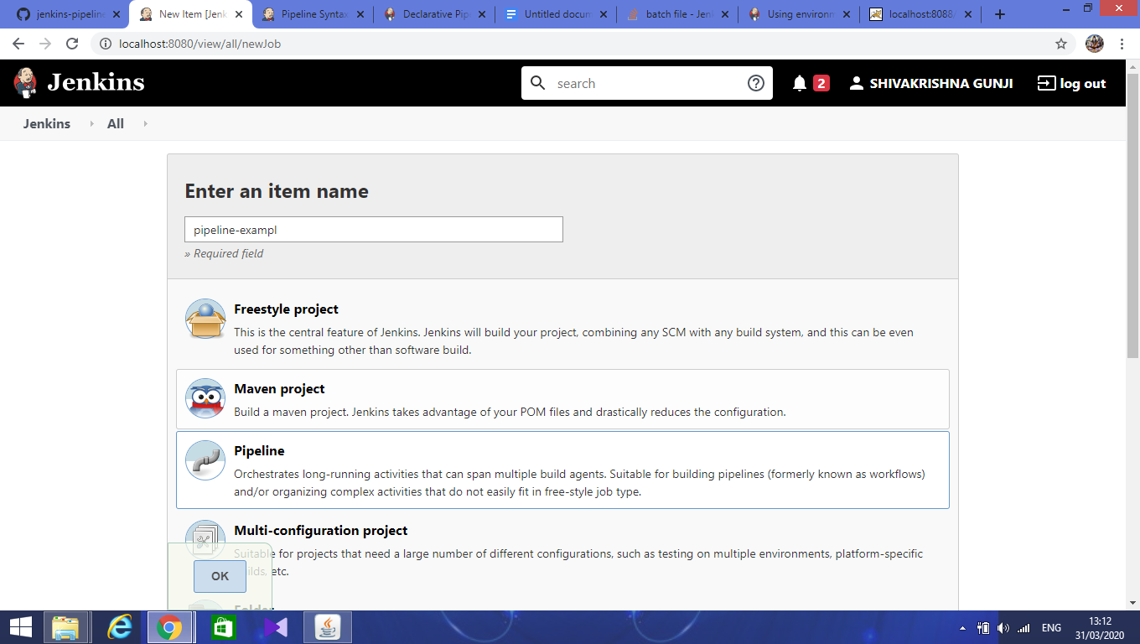

Configure the job in pipeline section

1. Select the **pipeline script from scm** option from **Definition**
2. In scm option select **Git**
3. In the repository section, give the repository link of github

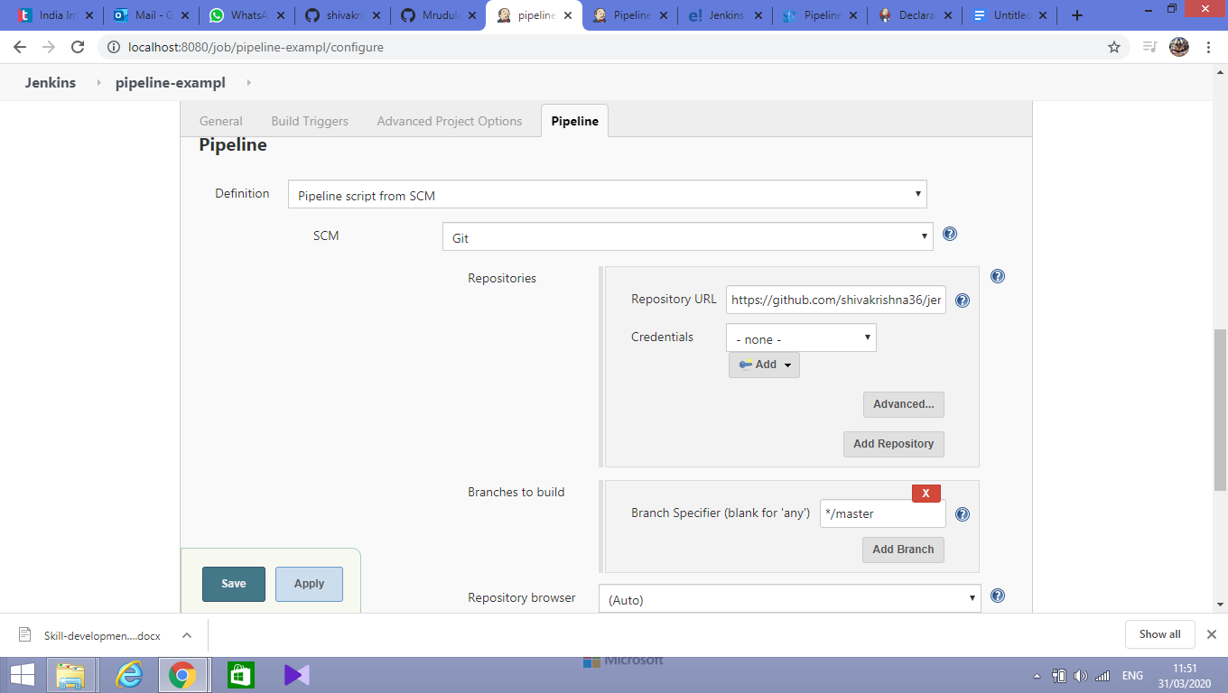

In **secret path**, give the name of Jenkinsfile which has pipeline script as shown:

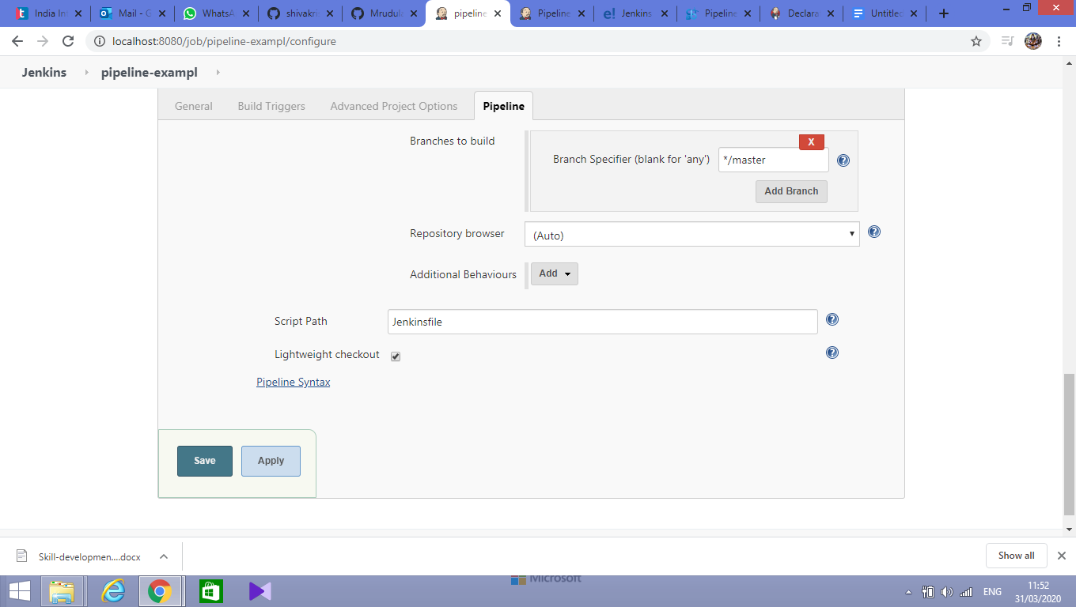

Click on **Apply** and **Save**

**Next, click on build now**

It will start building

A stage wise view is shown as follows:

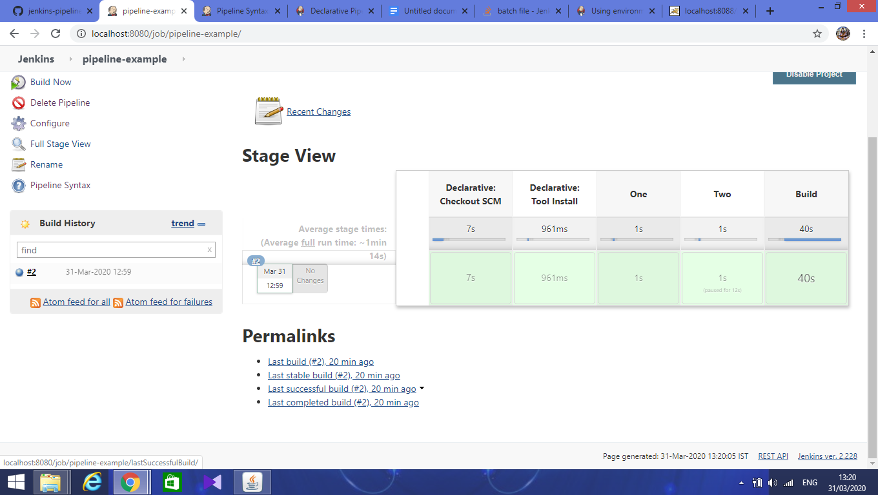

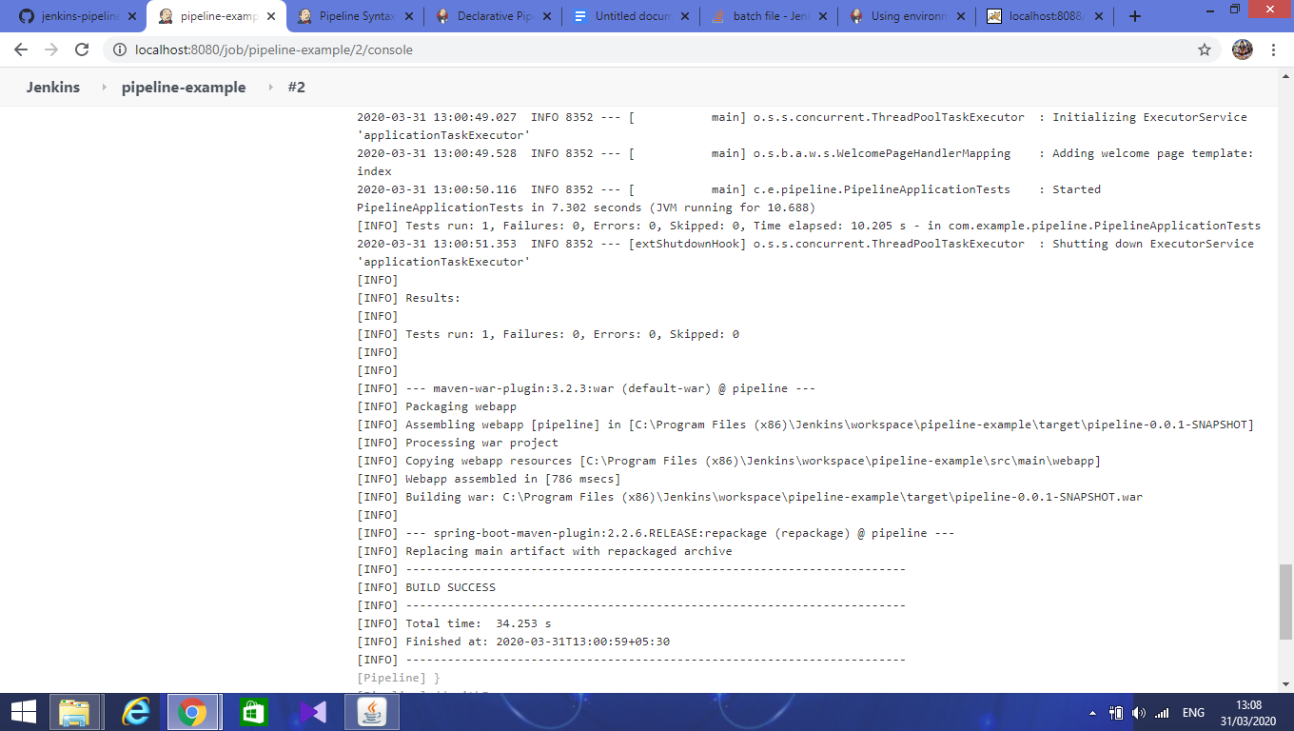

Console output is shown in above picture. Which is build successfully and generated war file successfully.

We can see the generated war file as shown below:

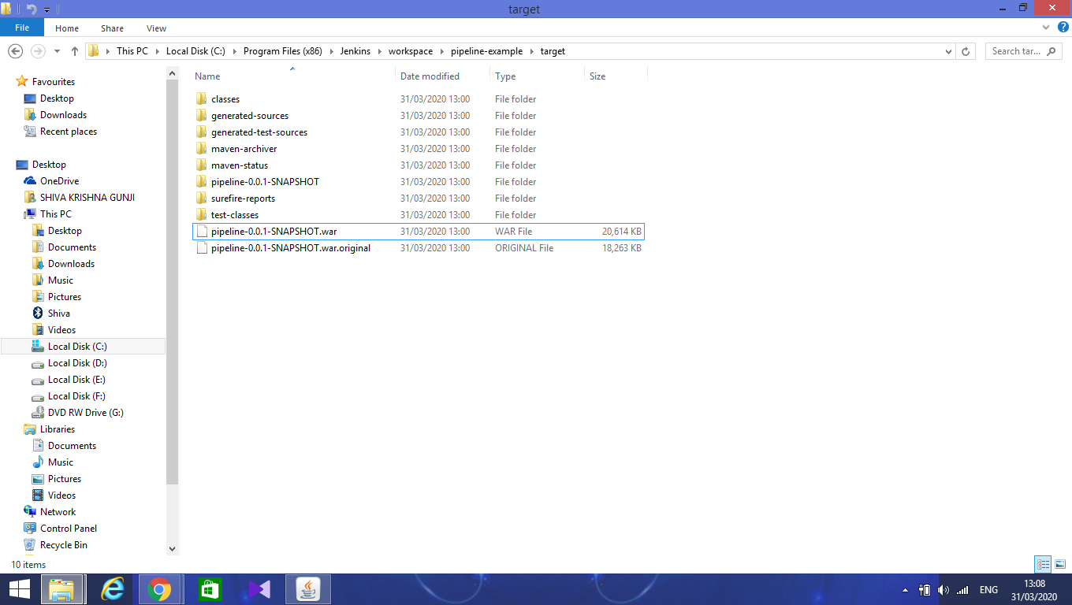

Next, copy war file in tomcat webapps folder and the start the tomcat server.

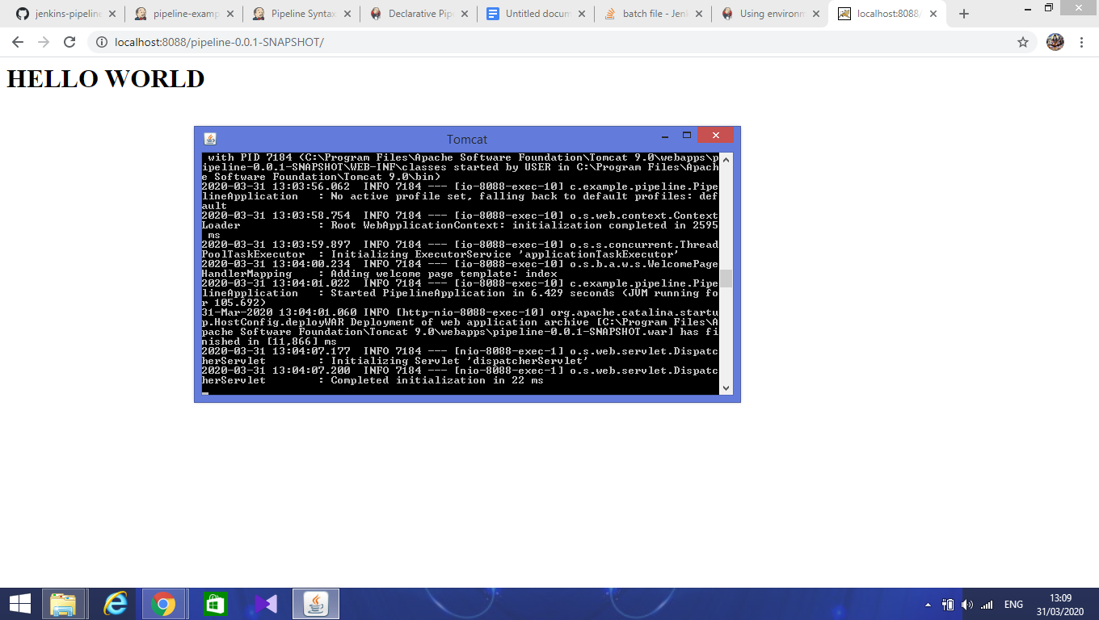



Finally, locate to tomcat url and add war file name to run as shown above.